2026-09-20
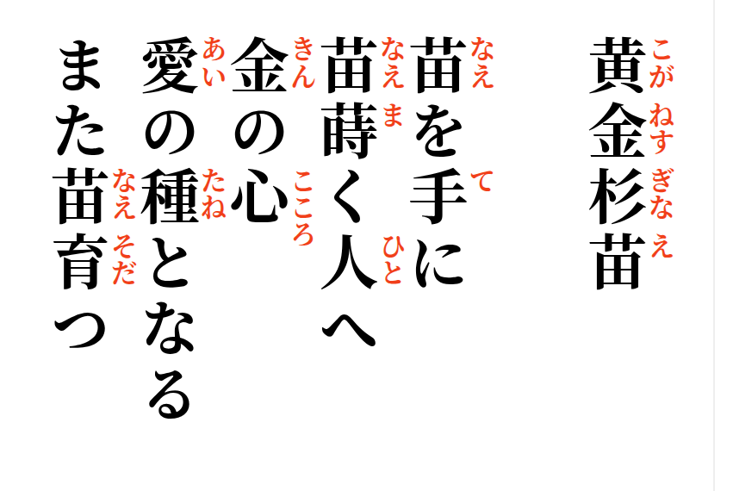

The Golden Sugi Seedling
A seedling in hand,
for the one who sows seedlings,
a heart of gold—
becoming a seed of love,
another seedling grows.

